EDA-EXPLORATORY DATA ANALYSIS REPORT
Dataset: Fake News Detection
Objective:
The purpose of this Exploratory Data Analysis (EDA) is to gain meaningful insights from the Fake News Detection dataset. This dataset consists of two parts:
- Fake News Articles
- Real News Articles
The analysis focuses on understanding the distribution, structure, and key characteristics of the data.

Data Loading & Preprocessing:
Two datasets were loaded:
- Fake.csv (Label: 0)
- True.csv (Label: 1)
Both datasets were combined into a single dataframe for uniform analysis. The labels were assigned accordingly:
- Label 0: Fake News
- Label 1: Real News
Dataset Overview:
- Total records: 44,898
- Features: title, text, subject, date, label
Data Quality Check:
- No missing values found in essential columns.
- Duplicate records: 356
Duplicates can be handled depending on model requirements.
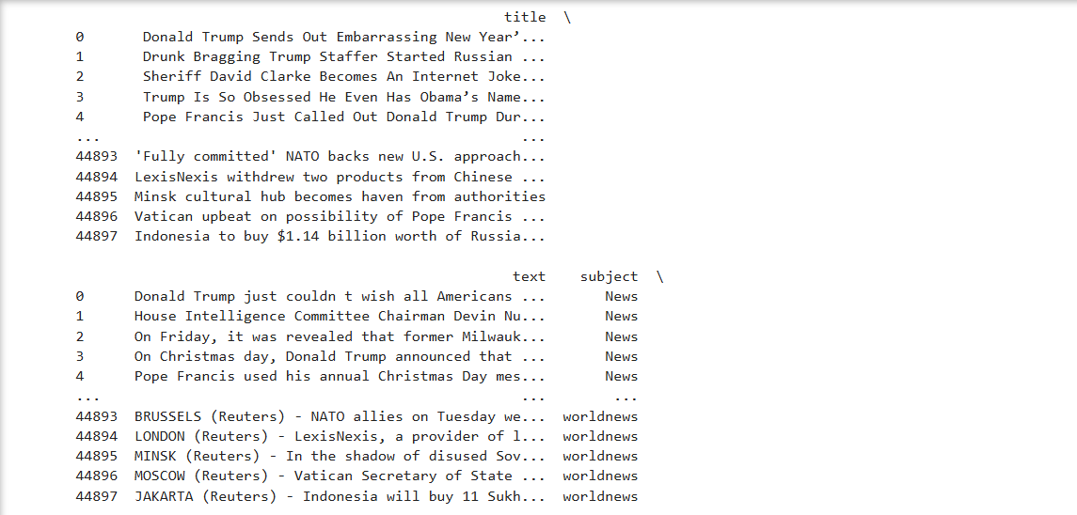
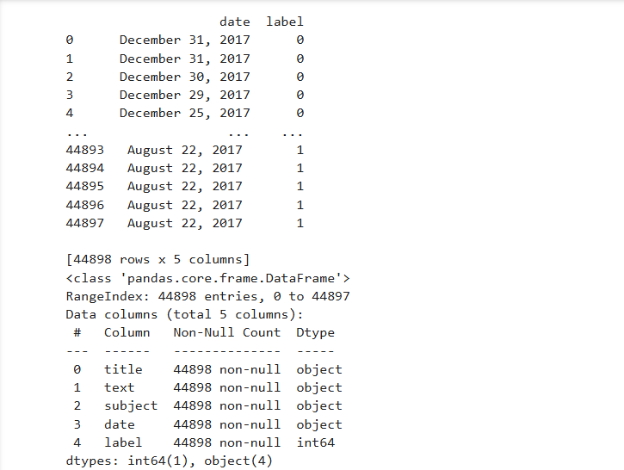
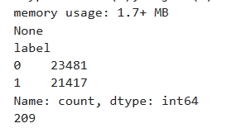

Class Distribution:
News Type | Count
Fake News | 21,417
Real News | 23,481
The dataset is relatively balanced with a slight dominance of real news articles.

Word Cloud Analysis:
Word Cloud for Fake News Titles:
A word cloud was generated after converting all words to lowercase and removing stopwords. The most prominent words were related to politics and global events.
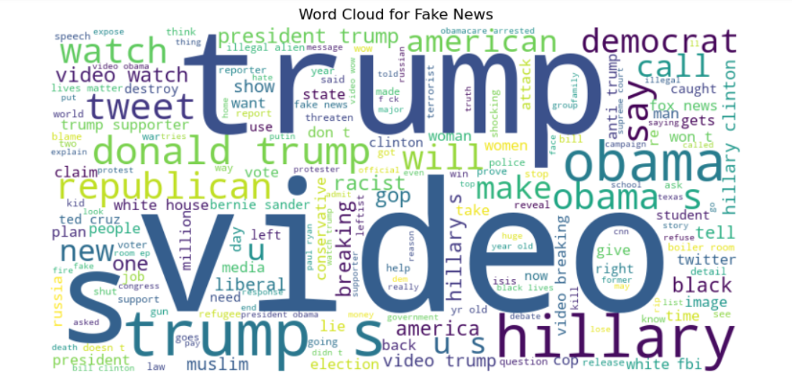
Word Cloud for Real News Titles:
Similarly, real news word clouds highlighted topics like US, government, people, and reports.
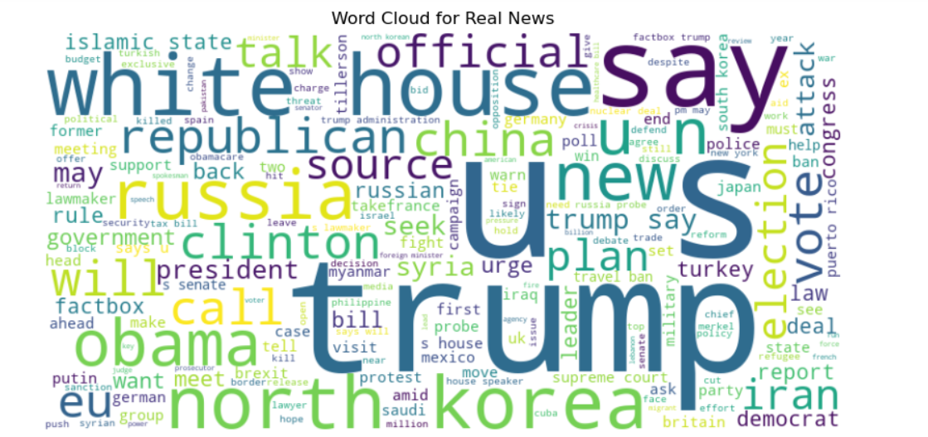
Word Cloud for Merged Dataset:
The combined word cloud provides an overall view of frequent terms across both fake and real news articles.
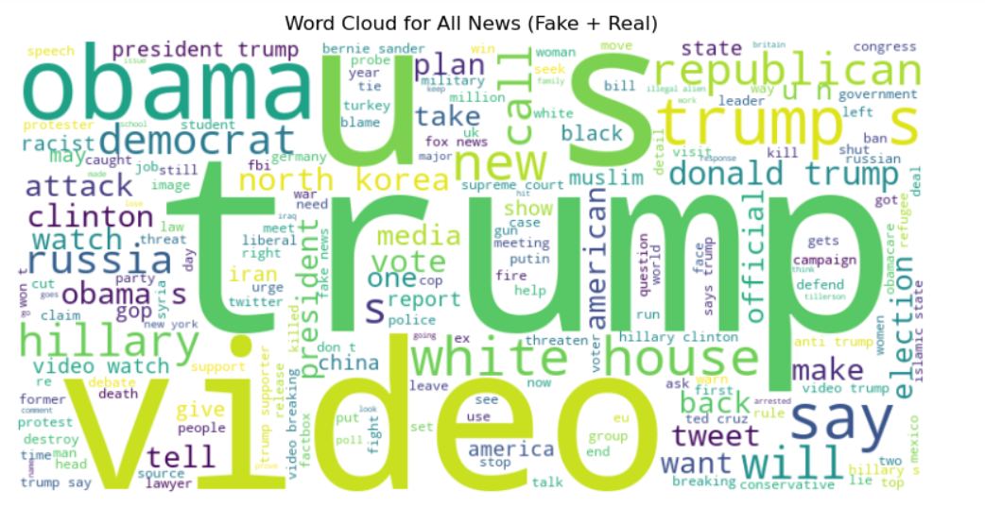

Word Frequency Analysis:
Most Common Words in Fake News:
Words like Trump, US, Hillary, Obama appeared most frequently, indicating a strong political focus in fake news articles.
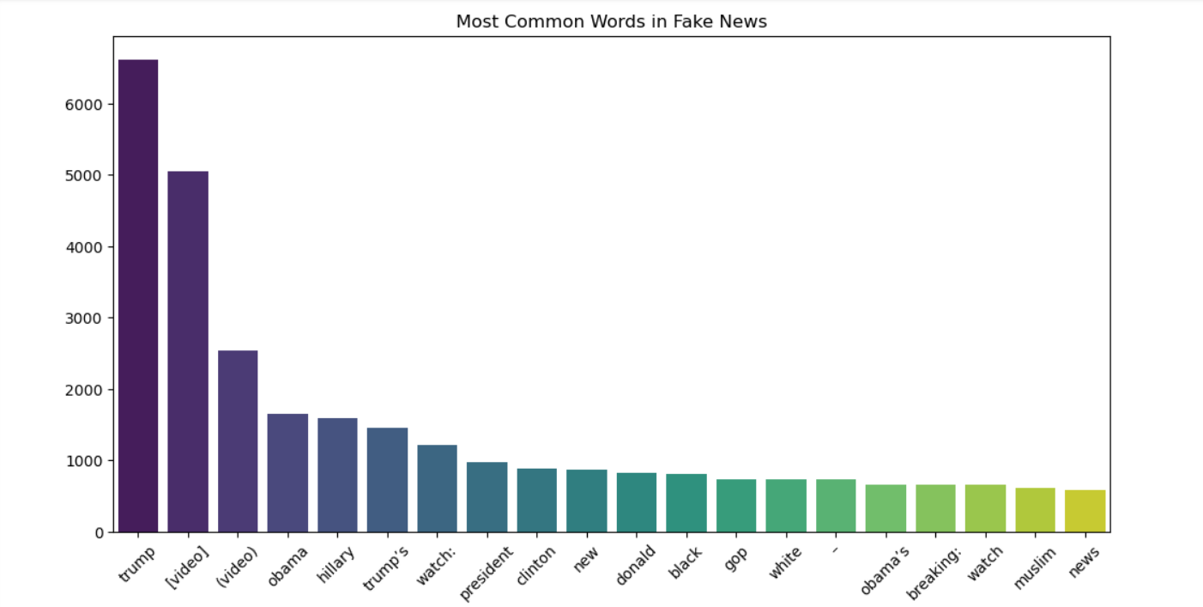
Most Common Words in Real News:
Words like Trump, US, said, people, government dominated the real news articles, showing a coverage of governance and global events.
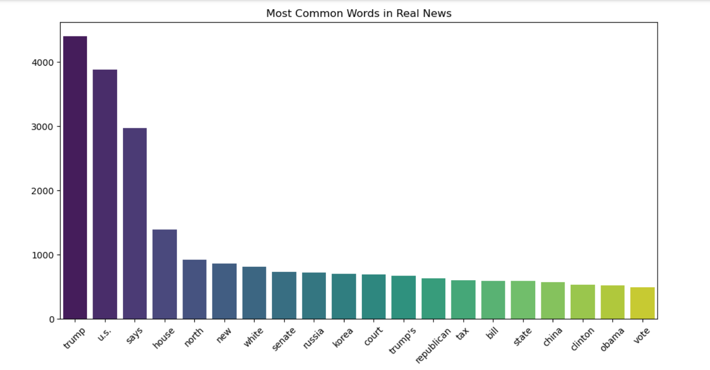

Article Length Distribution:
A histogram of article length (measured in words) was plotted for both fake and real news.
Observations:
- Fake news articles are generally shorter in length.
- Real news articles have longer content, possibly due to in-depth reporting.
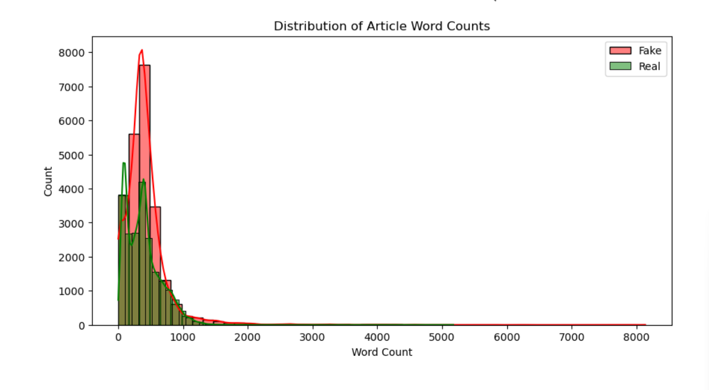

Conclusion:
This EDA provides significant insights into the nature of fake and real news articles. The analysis shows that political entities dominate both categories, with fake news articles being comparatively shorter. Word cloud and word frequency analysis help in identifying key themes and repetitive content within each label.
This report lays the foundation for further analysis like feature engineering, model building, and classification tasks.

